New client process
When a potential new client calls in,
We do not have base pricing for tax returns, we only do quotes based off the last 2-3 years filed tax returns.
New client Inquiry from (to be printed on Orange paper)
All new client Inquires are kept in a master binder at the front desk.
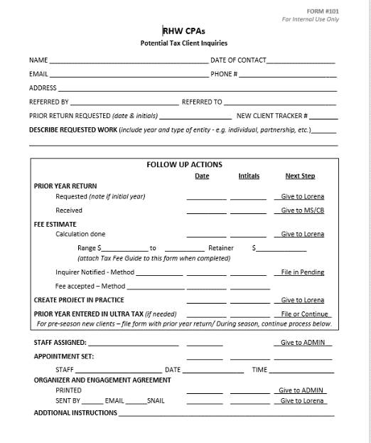

Take name, number, email address, and how they found our frim
Notes of requested services. (tax year, : personal, LLC/ 1120 C/S, nonprofit, tax planning)
When sending in documents, Drop off/ mail in, Portal, email ( we do not recommend email for security)
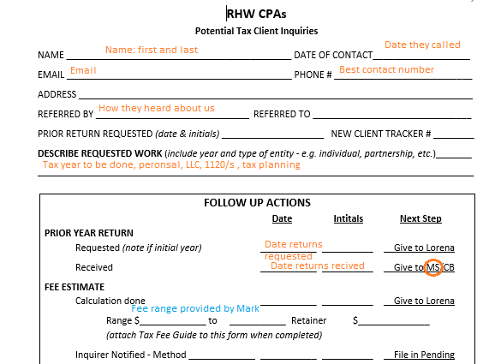
Setting up Portal for Potential New client
Log in to the New client portal
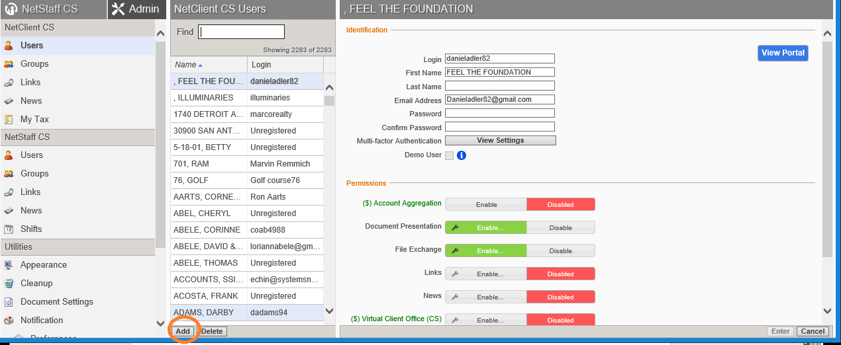
Select “ADD”
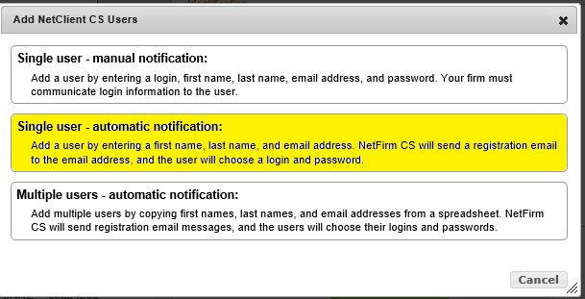
Input name first and last and email
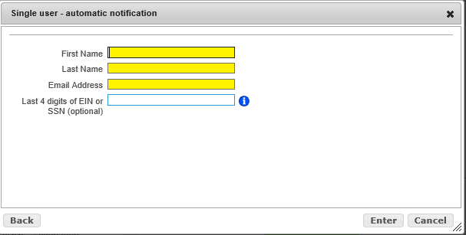

In the “Permissions” select “File Exchange”
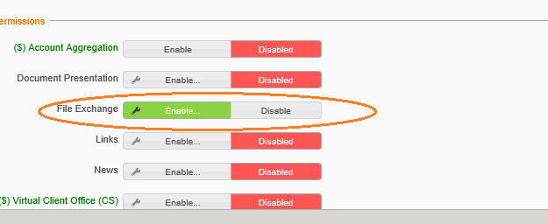
Select “Actionable items from RHW CA” and “Documents to RHW”
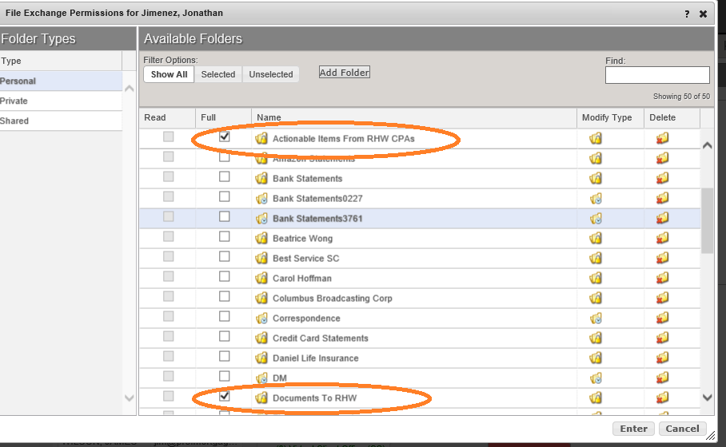

Email Potential new client with new portal instructions,
Good Morning Mr/Ms Smith.
I have set up the New client Portal
Attached are the instructions to set up the portal, the multifactor auth, as well as how to upload to the portal.
Please upload the last 2 years of tax returns for review.
Please contact the office if you have any questions.
Thank you
Kristen Story

Set up client folder in GFR:
Chose the “Prospects” file in GFR

Set up project in Practice:
Go to the “Prospects “ client ID in practice.
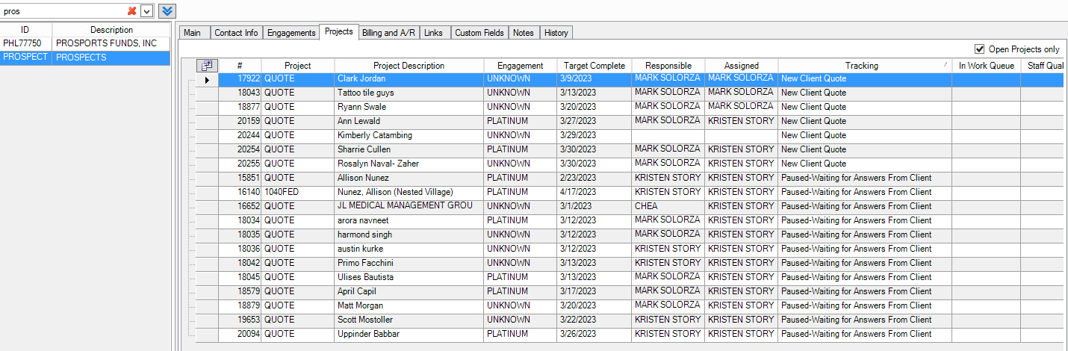
- Select project title “New Client Quote”
- Description “Potential Client name”
- Engagement : Platinum
- Tracking : New Client Quote
- Responsible : Mark Solorzano
- Staff: KS
- Notes: Note stage the quote is in.
- I.E : potential client called in, portal set up/ dropping off docs
- Include date and initials all notes
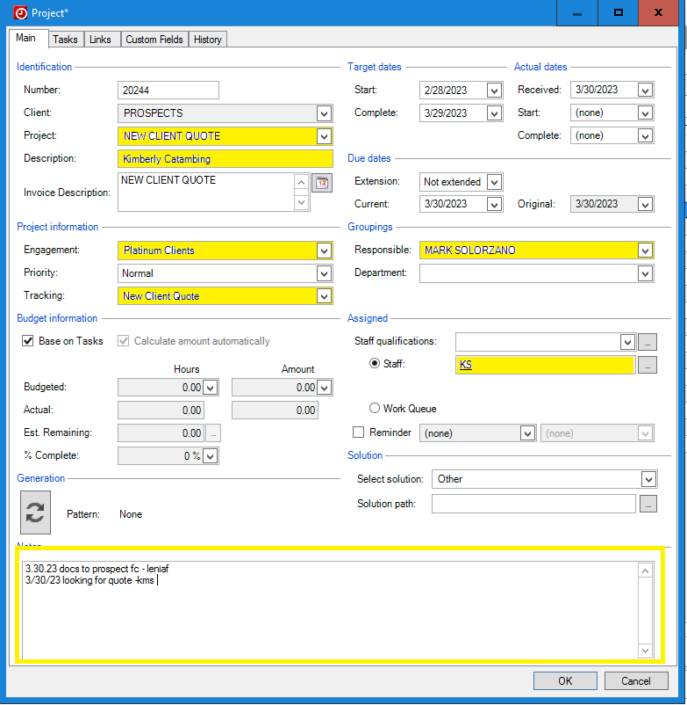

When the returns have been uploaded to the portal/ dropped off or mailed in:
- Move returns to prospect file
- Note when returns were received in project and on the orange sheet.
- Give orange sheet to Mark
Quotes take anywhere between 1-3 days to process depending Marks work load.
Tell the Potential new client it will take up to 3 days, (72 business hours) for the quote to be completed
Mark will email the quote excel sheet to front desk and Chea for review. Once Chea has reviewed and advised quote is good.
- Add a note of the quote fee in all CAPS to notes in project and that Potential New Client was contacted.
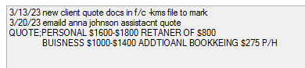
Email Potential new client quote:
Good afternoon Mr/ Mrs Smith
We have completed the quote for the processing of your (year) tax returns.
The fee range will be: $ (low end) to $(high end) with a deposit of $ ______
Please let me know if this is acceptable and we will send over the engagement agreement to you via DocuSign, and will put the Invoice for the deposit on your portal
Please let us know if you have any questions.
Thank you
Kristen Story

If quote is accepted:
Lorena Biggs ( office manager ) will created the Client ID in Practice and in File Cabinet.
She will also create the Engagement agreement with the fee quote and retainer.
Once this is created and saved in File Cabinet she will bring the orange New Client Form #101 back to the front desk to send the Engagement Agreement via DocuSign

Sending DocuSign:
https://account.docusign.com/
Login: rhw@rhwcpas.com
Password: RHWpass2023!
Search new client in GFR :

*Pull the current year Tax Engagement Agreement to the Desktop
* will either be in the Current tax year ( Tax 2022 or Not Yet Filed)
* In the DocuSign site
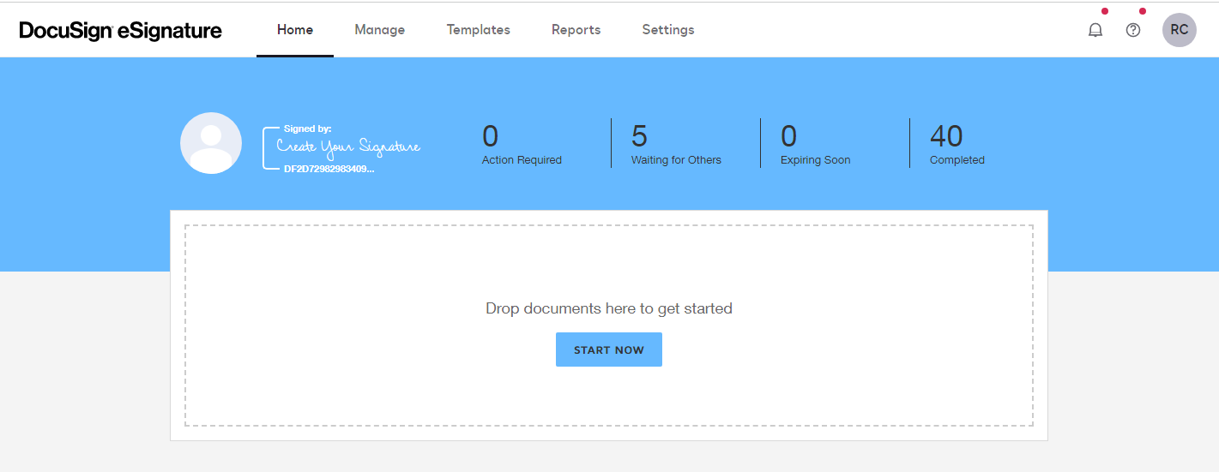
- Drag saved Engagement Agreement to the box that says “START NOW”
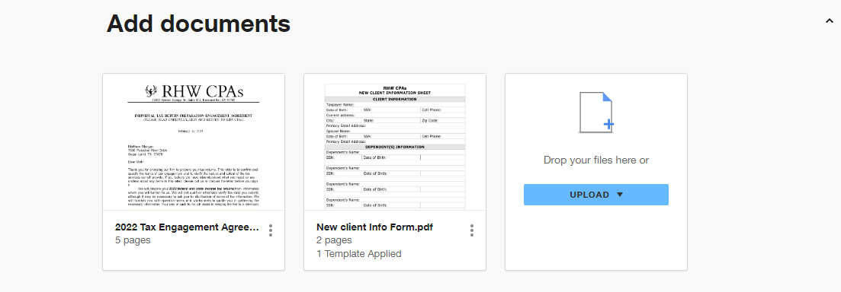
- The new Client Form is located in Templates
  - Click the Blue UPLOAD bottom
  - Select “ Use a template”
  - Chose New client Form from the templates
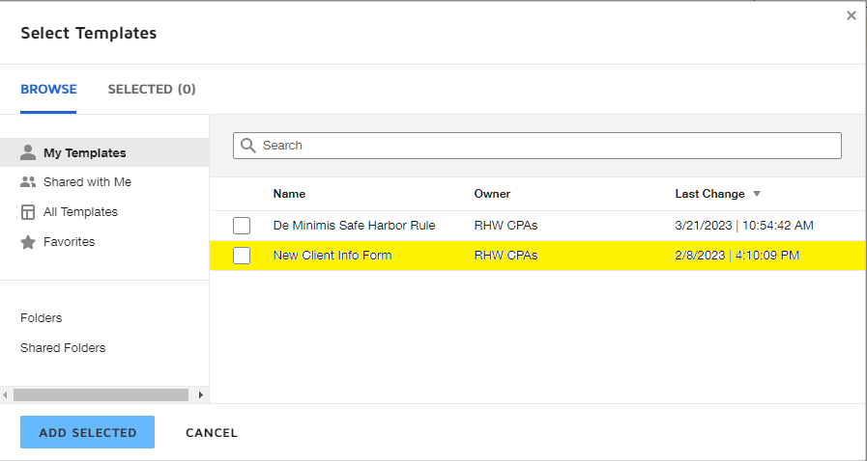
- Scroll down ADD RECIPIENT
  - In put name and email
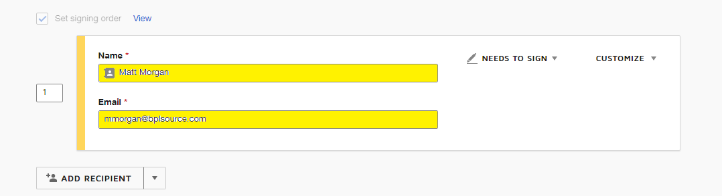
- Scroll to Add message
- Subject line : Complete with DocuSign : 2022 Tax Engagement agreement & New Client info Form
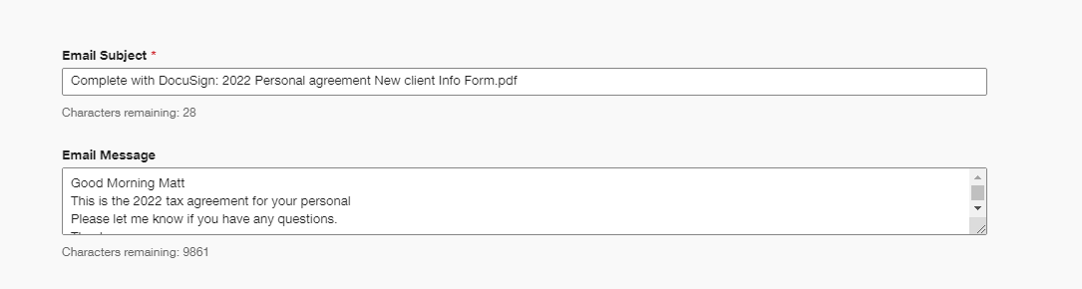
Select NEXT at the bottom right of the page
- This will bring up the editing page to add Names, Signatures and other info to the forms
- Scroll down to the signature lines in the Engagement agreement
  - Add FULL NAME
  - Add SIGNATURE
  - Add DATE SIGNED
Client on the left side of the page for the desired information to be filled in, and drag to place the box on the desired line
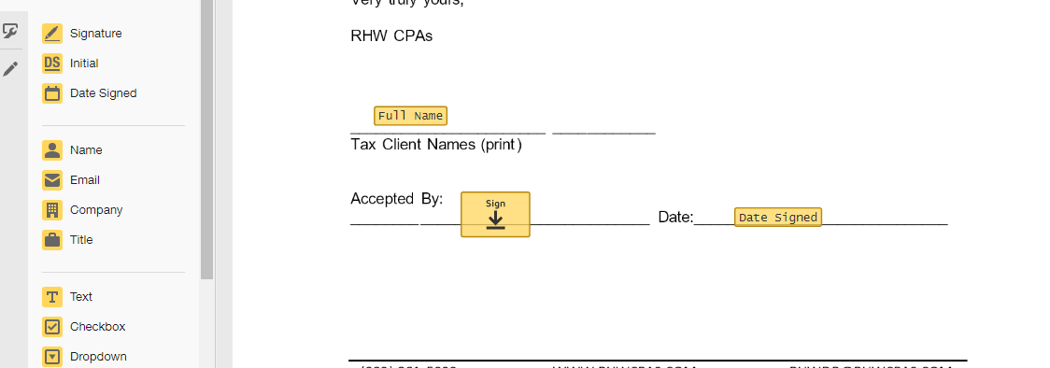
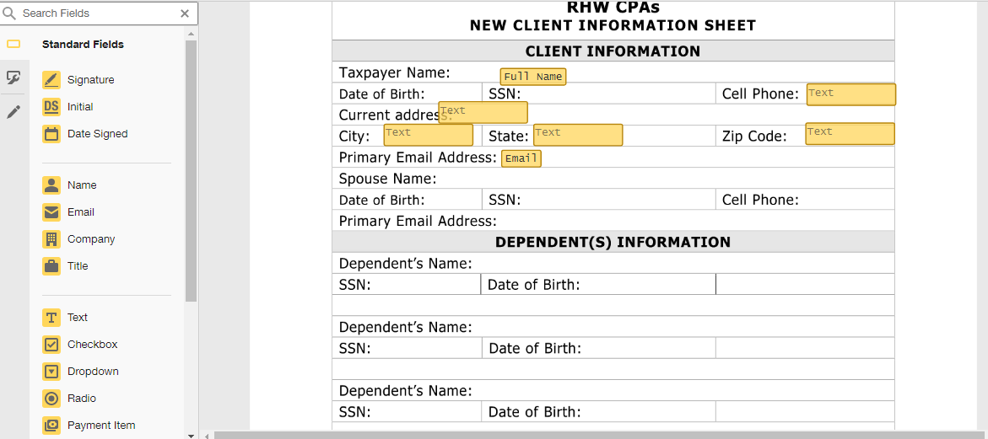
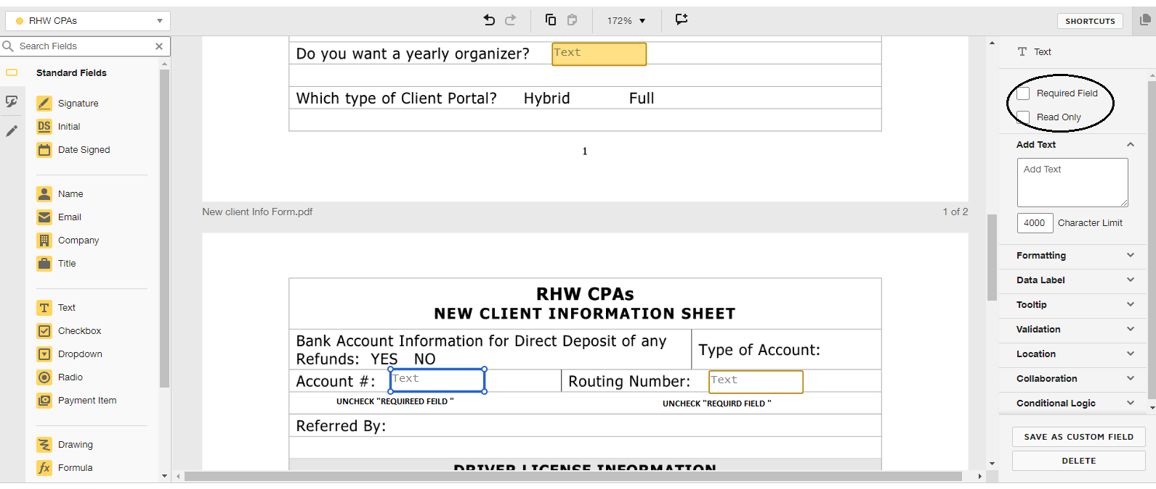
    - For the account and Routing Numbers, uncheck the “ required field in the upper right corner, this will allow them to input data if desired.
- Select SEND
Moving documents in File Cabinet: Moving the past returns to the new client ID
- Save the returns BY YEAR to desktop and then save them to the new client ID in file cabinet
( see the SOP for saving to File Cabinet)
- Note that the quote was sent to the new client and complete the project in Practice in the Prospect folder
- Create a new project in the new client ID for the tax returns,
  - Assign Segmentation:
    - Bronze $200-$600
    - Silver: $600-$800
    - Gold: $800- $1000
    - Platinum: $1000 and above
NOTES: 4/4/23 New client for tax year 2022, engagement agreement sent via DocuSign- KMS
If quote is declined:
If the quote fee is declined, note the project and complete,
Email response to decline of quote:
Thank you for considering RHW CPA’s for your tax preparation
We will delete the portal as well as any submitted documents.
Please let us know if you will need our services in the future.
Thank you
Kristen Story
- In the portal : delete the New client portal that was created
- In File Cabinet: Delete the submitted returns
- Right click on the client name and select “Drawer Properties”
- Delete Client name form the Prospects folder

If no returns (company’s first year in business, or does not have the return) :
- If New Client for Business is calling for a quote but this is the frist year of business,
- Request :
  - Balance Sheet : for the tax year in question
  - Profit and Loss statement : for the tax year in question.

New payroll quote :
- Payroll Inquiry sheet.
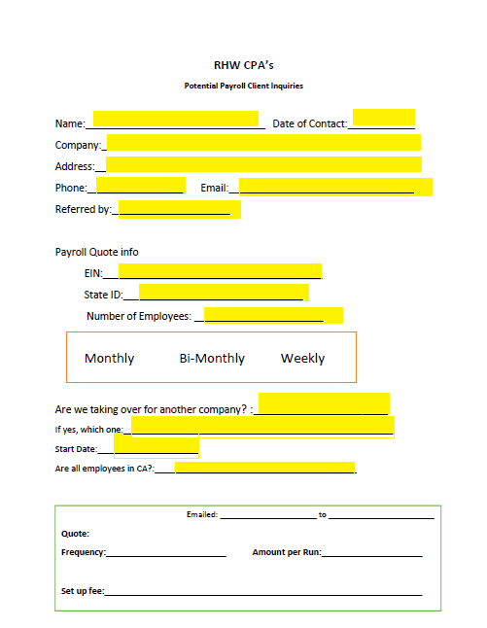
- Must have for quote
  - EIN number/ State ID
  - Number of Employees
  - Monthly
  - Twice monthly, (Bi Monthly)
  - Taking over for another company
  - What states are the employees from
-We can apply for the State and EDD numbers for them if needed
- Create project in the Prospects in Practice
- Create file in Prospects folder in File Cabinet for uploaded returns.
- Create portal
- Send payroll quotes to Cory Cooper, Nancy Quesada, and Chea Romine
- Cory will respond with quote fee, fill out quote info in the bottom office use only box
- Add note of the quote in all CAPS to the project
- Email quote to New client.

Sending payroll engagement agreement:
- Request the Federal EIN letter for the file
- Payroll sheet to Lorena to make the client ID.
The payroll agreement documents are located:
Data(\\RRDS) (P: ) > Schadler Documents> Documents>Payroll>_Memos> New Payroll Clients
- There are monthly payroll clients and Quarterly Payroll clients
- Word doc: Engagement for Payroll Services,
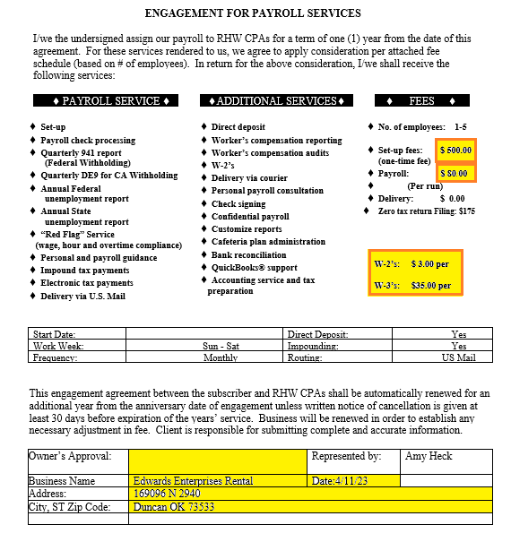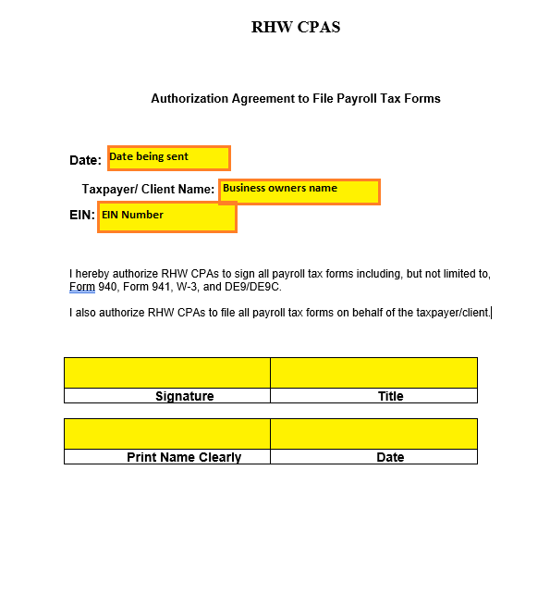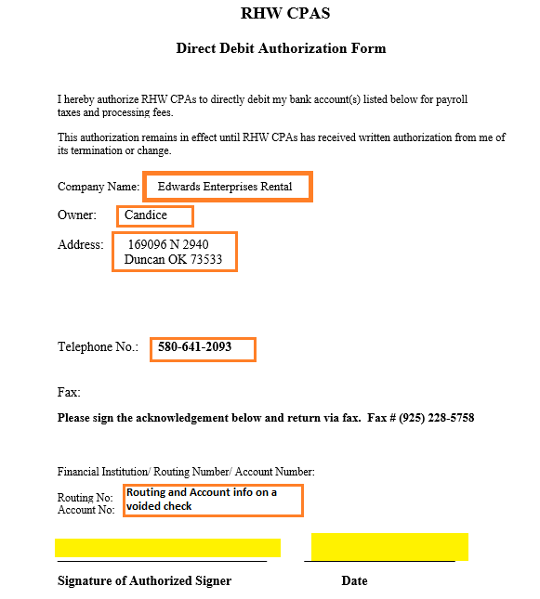
- For page 1: enter in the quoted fees for set up, payroll ( by run) and for the W-2’s and W-3’s
  - Bottom of page 1: Name of business, address, date the agreement is being sent.
- For page 2: Date agreement is being sent, Owner’s Name and the EIN number
- For page 3: Name of business, Owners name, Address.
*Signatures and account information will be requested through DocuSign
- Form 8655
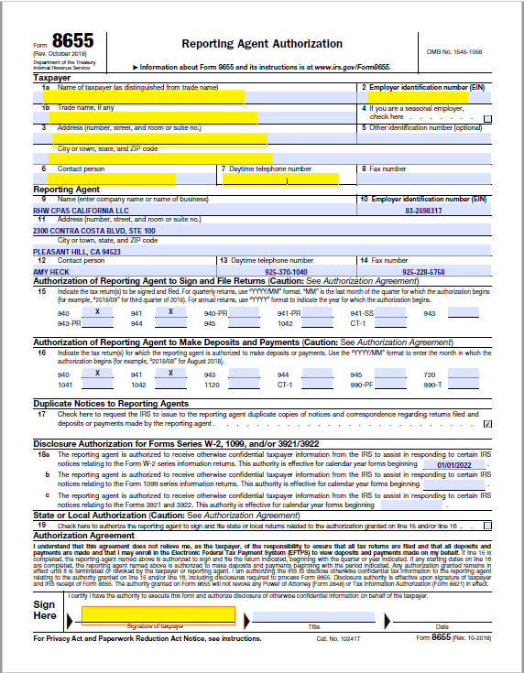
  - Enter Name of Business, address, contact, EIN and Owners Name and number
  - This is one page.
Sending Payroll agreement through DocuSign
- Login to DocuSign
  - Login: rhw@rhwcpas.com
  - Password: RHWCPAs2@
- Save copy of the edited Payroll agreement and Form 8655 to desktop
- Drag both to “START HERE”
- Enter Name of Business owner or contact and email
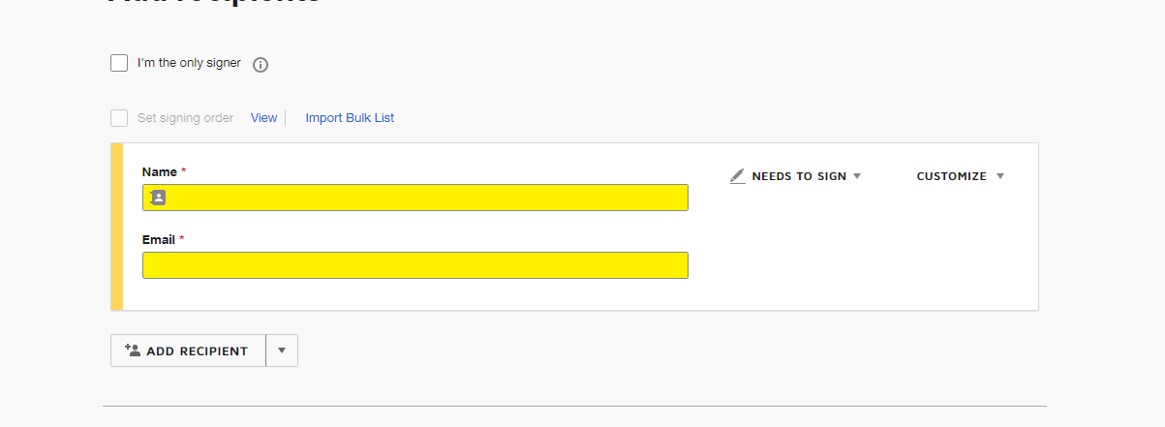

- Enter message
Good afternoon
Welcome to RHW! Here is our payroll engagement agreement. Please contact the office if you have any questions.
Thank you
- Page one Signatures:
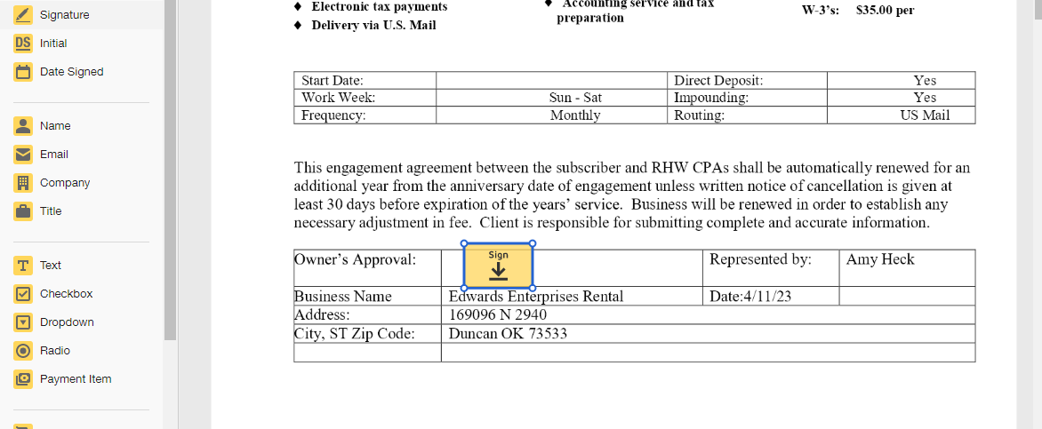
- Page 2 Signatures:
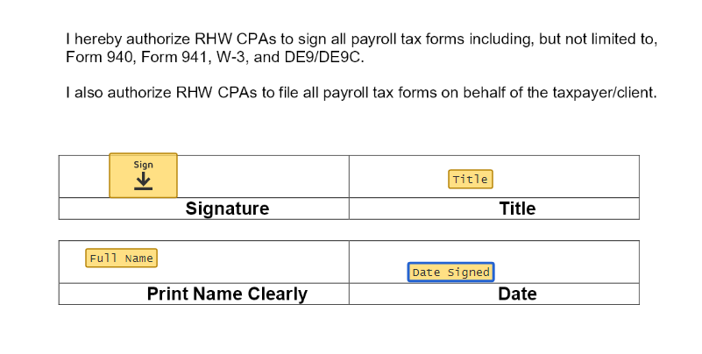
- Page 3 Signatures:
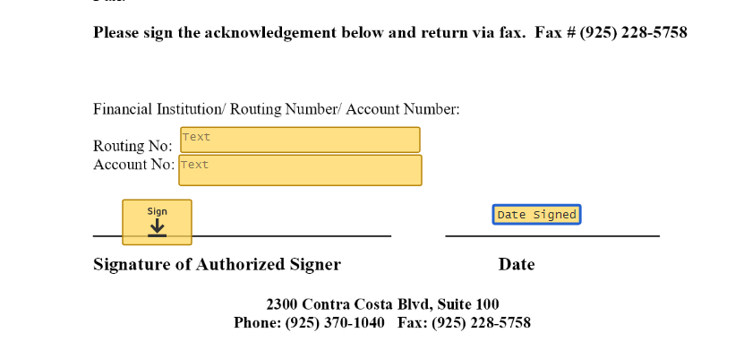

- Form 8655 Signatures:
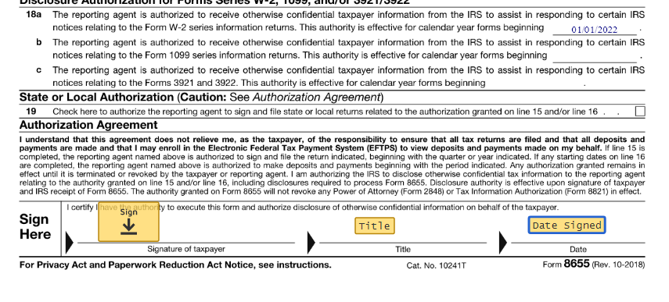
- Send to the contact.
- Save a copy to GFR.
New Bookkeeping quote:
- Bookkeeping Inquiry form
- 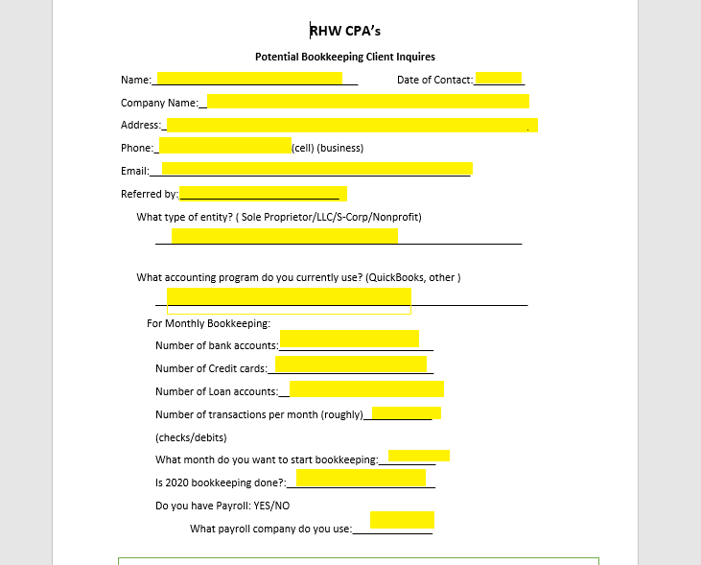
- Email information to Cory Cooper, Amy Heck, and Chea
Sending Bookkeeping Engagement agreement
- Lorena to make the client ID
- Rosanna will send the Bookkeeping agreement either through DocuSign or email.

Master forms for Tax/Payroll/ Bookkeeping quotes:
- Located in the P drive
- Data ( \\RRDS) ( 9: ) > New Client Inquiries
- Print on ORANGE paper only.
- Put in binder for new client quotes

